Carcinoma Oropharynx
Anatomical considerations

Oropharynx extends from the level of hard palate superiorly to the level of hyoid bone inferiorly. Its anterior limit is anterior faucial pillar which is contiguous with retromolar trigone.

It is a small mucosal area on the mandibular ramus, behind the last molar tooth, continuous with the maxillary tuberosity. The pterygomandibular raphe, just under the retromolar trigone mucosa, connects the pterygoid process of the sphenoid bone with the myloid ridge on the mandible; on this raphe, the buccinator muscle and superior pharyngeal constrictor muscle attach. By virtue of its location, the retromolar trigone is at the crossroads of the oropharynx, nasopharynx, buccinator space, floor of the mouth and parapharyngeal space
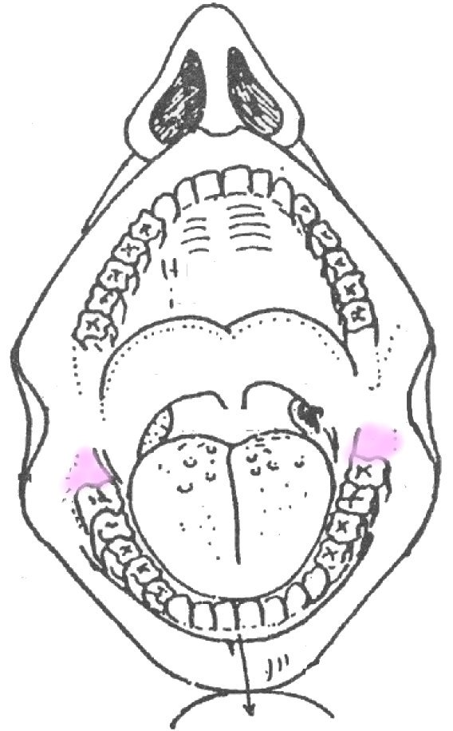

The Anterior wall is made up of base of tongue, the valeculla and lingual surface of the epiglottis. It is further bounded by pharyngo-epiglottic folds.
The Lateral wall is made up of anterior pillar, palatine tonsil and posterior pillar.
The roof is by soft palate (containing palatopharyngeus, levator palate and palatoglossus muscles). The oral surface of soft palate is part of oropharynx and the nasopharyngeal surface is part of nasopharynx.

The posterior wall extends from level of hard palate to the level of hyoid bone and is anterior to second and third cervical vertebrae. It comprises of superior and middle constrictor muscles and buccopharyngeal facia which separates it from prevertebral facia.
The lateral wall of the oropharynx is medial wall of parapharyngeal space. If a tumour extends through lateral wall of the oropharynx, it enters the parapharyngeal space and becomes contiguous with carotid sheath, the sympathetic chain, stylopharyngeus and styloglossus and pterygoid muscles.
Tumors of the posterior wall extend upwards into nasopharynx and down into hypopharynx and are best considered as part of contiguous regions.

The most important part area in the oropharynx however is the tongue base. This is made up of genioglossus muscle, which is attached to hyoid bone. Tumour infiltration into this muscle by definition almost always involves whole of the tongue. Further more the base of tongue is contiguous with valeculla, which is the roof of the pre-epiglottic space (PES). Early spread in to PES means that a tongue tumour rapidly becomes a laryngeal tumour.
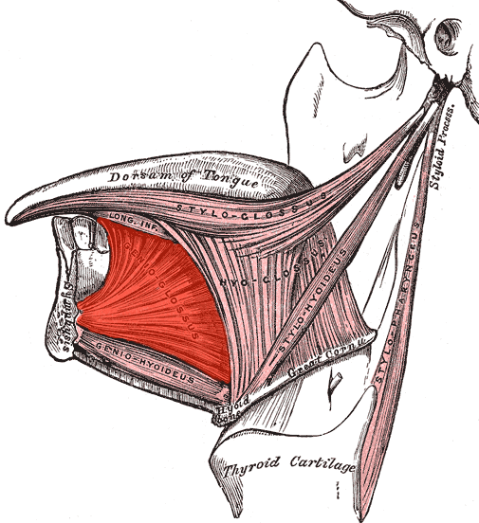
The lymphatic drainage of the oropharynx is to the level II, III and IV lymphnodes with an emphasis on jugulo-diagastric nodes in level III. It also drains in to retropharyngeal and parapharyngeal lymph nodes.

The oropharynx is lined by squamous epithelium hence squamous cell carcinoma represents the most common tumour. However there is abundant lymphoid tissue in the palatine as well as lingual tonsils, which gets involved with head and neck lymphomas. Soft palate is especially rich in minor salivary glands.

- Squamous cell carcinoma is most common malignancy and forms 90% of tumours of this region. The most common sites involved are:
  - Lateral wall (60%)
  - Tongue base (25%)
  - Soft palate (10%)
  - Posterior wall (5%)

- Lymphomas :
  - Lateral wall (90%)
  - Tongue base (10%)
- The minor salivary gland tumours have a predilection for soft palate.

Staging of the oropharyngeal tumours is based on size:

- T1- Tumour measuring 2 cm or less in size.
- T2- Tumour measuring more than 2 cm or less than 4 cm in size
- T3 - Tumour measuring more than 4 cm in size in its largest diameter
- T4 – Tumour invades adjacent structures e.g. Pterygoid muscles, mandible, hard palate, deep muscle of the tongue or larynx.

Tumour spread:

Lateral wall tumors: Most common tumour (50%) and often involves tonsil.

Anteriorly spreads to retromolar trigone, on to buccal mucosa as well as muscles of tongue base. If the invasion gets deeper the pterygoid muscles are involved resulting in trismus. Lateral spread involves angle of mandible. Inferiorly the growth spreads to involve lateral pharyngeal wall and pyriform sinus. The aryepiglotic folds and para-glottic space are involved subsequently.

The lesions of the lower pole are often difficult to see and some times primary tumours can lurk with in tonsillar crypts as ‘occult primaries’

Base of tongue tumours: Next most common oropharyngeal tumours. Symptoms frequently do not appear unless lesions are at an advanced stage. They spread through genioglossus muscle and across midline and very quickly involve entire tongue. Muscle contractions of the genioglossus help to propel the tumor cells not only into lymphatic system but also through potential spaces with in intrinsic tongue.
- 60% to 70% of patients have positive palpable lymph nodes on presentation.
- 20% to 30% have bilateral lymph nodes..
- 20% of patients will present with neck nodes and no apparent primary.
- It is important to assess retropharyngeal lymph nodes.

Soft palate tumours: Occur almost exclusively on anterior surface. It may occur with leukoplakia and is most common with heavy smokers or tobacco chewers. They involve palatine nerves, back of the maxillary antrum and superior pole of the tonsil.
The lymphomas particularly affect younger individuals, who present with unilateral tonsillar enlargement.
Minor Salivary glands: In case of soft palate most minor salivary gland tumours are pleomorphic adenomas. Elsewhere malignant tumours are the rule and include adenoid-cystic and muco-epidermoid types.

The presenting features of oropharyngeal tumours include:

- Sore throat
- Otalgia
- Dysphagia
- Ulcers
- Pain
- Trismus
- Neck masses

Majority of patients present late.

Investigations:

Radiology: The objective is to assess size of the tumour and any perineural or deep spread of the tumour.

- CT/MRI is done to evaluate tongue base. To see the laterality of the lesion
- The treatment of soft palate and tonsillar lesions depends upon size of the tumour. MRI is modality of choice.
- It is important to assess any mandibular invasion
- Orthopantogram
- CXR
- US
- CT chest/abdomen

Biopsy: Panendoscopy under GA is done to assess size, site and extent of primary tumour, to take a biopsy, to look for metastatic disease and synchronous lesions and to assess neck.

- Incisional biopsy
- If there is smooth regular involvement of tonsil then tonsillectomy
- Deep biopsy for base of tongue
- FNAC of the tongue mass

Treatment policy:
Curative:
- Radiotherapy
- Surgery
- Surgery plus post-operative radiotherapy
Palliative:
- Radiotherapy
- Radiotherapy and chemotherapy
- Tracheostomy
- Pain relief

Radiotherapy has been shown to yield better functional outcomes in similar local regional control. The local regional control and overall survival at five years is similar for either radiation or surgery. But, for the most part a higher complication rate, in particular a fatal complication rate, of patients treated with aggressive surgery.

N1 or N0 necks are usually treated with a single modality, either radiation therapy or neck dissections.

N2 and N3 disease or advanced neck disease is usually recommended by combined modality.

How do we treat patients with advanced disease?
Chemo radiation: These chemoradiations aim to improve survival rates to greater than 40%, and to try to minimize morbidity. There are really two main combinations of chemoradiation therapy: induction chemotherapy as well as concomitant or concurrent chemoradiation therapy.

In induction chemotherapy, initial chemotherapy is followed, after the chemotherapy, by radiation therapy. There have been several trials, and they show that induction chemotherapy is active against inducing disease remission in up to 80%-90%. But the randomized trials have failed to demonstrate a clear importance of induction chemotherapy on local control and overall survival.
Salvage Surgery: We are seeing more and more salvage surgery these days because the treatment modality is really shifting to chemoradiation. The goals of the surgery are different. If the patient fails radiation therapy, usually they are presenting with advanced disease, and the surgery we were performing has a success rate of less than 15% for this advanced pathology. The goals of our salvage surgery these days are really to help control, more of a palliative function, with regards to helping control pain as well as fistulas and what not.
Another thing that we are seeing is salvage surgery for residual neck disease

Lateral wall tumours:
- TI, T2 N0 lesions have a 70% survival rate
- T3 T4 lesions have a 30-40% survival rate
Tongue base:
- If detected early they can be treated with external beam radiotherapy with 80% five year survival rate
- In advanced cases neck dissection with post operative radiotherapy of primary tumours.

Commando Operation: (Combined mandibular oral cavity resection)
Indications:
SCC tonsil with metastatic lymphnodes
Recurrent Carcinoma of lateral wall after radiotherapy
Malignant salivary gland tumours of lateral wall and soft palate

